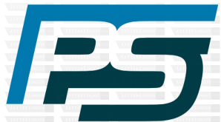
PIONEER SERVICES

PS/SE/001/02/25. Jan 20th , 2025.

M/S NASTP
Silicon Valley, Karachi.

Request for Release of 20% payment for Smoke Extract system Integrated with Fire Alarm System for building No S2, S3 & S4 at NASTP Silicon Valley Karachi.

It is intimated that 50% work of installation of Smoke Extract system has been completed. It is therefore requested that 20% payment amount to Rs 3,778,900/- may please be release as per payment schedule.

Thanking you,
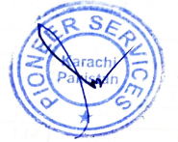

Sincerely yours,
For PIONEER SERVICES.

